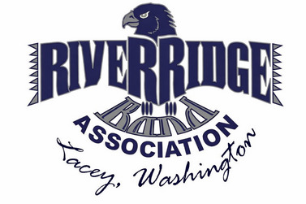
River Ridge Band Association (RRBA)

Membership Form
(Please print)
Name: _______________________________________________________
Mailing Address: ______________________________________________
____________________________________________________________
Phone: _________________________ ☐ I can receive text messages
Email: ______________________________________________________

Membership Type (choose one — must be 21 or older)
☐ Household Membership – Parents/guardians of current band students (up to 2 adults per household)
☐ Advisory Membership – NTPS employees, Band Director/Advisor (non-voting)
☐ Community Membership – Alumni, community members, or business representatives (non-voting)

Ways to Get Involved
☐ Volunteer | ☐ Join a Committee |  | ☐ Chaperone
☐ ___________________ | ☐ Band Camp | ☐ Food & Hospitality | ☐ ___________________
☐____________________ | ☐ Field Show | ☐ Fundraiser | ☐ ___________________
☐ ___________________ | ☐ Craft Fair | ☐ Uniform | ☐ ___________________
☐_____________________ | ☐ Transportation & logistics |  | ☐ ___________________
☐ Donate Supplies | ☐ Fundraising Support |  | ☐ Other: _______________

☐ I am an approved NTPS volunteer ☐ I hold a valid food handler’s permit
☐ I hold a basic first aid certification ☐ I have musical experience in:
Communication Preference
☐ I authorize RRBA to share my phone/email with other committee chairs and members for association activities.

Volunteer & Chaperone Requirements
All volunteers must:
- Be a current RRBA member
- Be NTPS-approved (application, background check, required training).
All chaperones must also:
- Be a current RRBA member in good standing.
- Follow RRBA chaperone rules and student supervision guidelines.
BAND Director Discretion:
The Band Director shall determine which volunteers may supervise students during trips and events. Selection is at the Band Director’s discretion and may consider program needs, safety requirements, and volunteer suitability. Approved volunteers must meet RRBA membership standards and NTPS clearance requirements.

NTPS Clearance Verification:
Proof of NTPS clearance must be submitted to and maintained by the district. The Membership Director or Board-designated officer will verify clearance.
Non-members assisting at a single event must follow the Event-Specific Guest Helper guidelines and sign the appropriate acknowledgment.

Agreement & Conduct
By signing below, I acknowledge and agree that:
- I am serving as a volunteer in an unpaid capacity.
- I will comply with all RRBA and NTPS policies.
- I will promptly report any safety concerns, conflicts, or incidents
- Failure to comply may result in the loss of volunteer or chaperone privileges.
- If chaperoning, I will supervise students responsibly.
- I understand and agree to the NTPS & RRBA Volunteer Policies and Handbook. https://www.ntps.org/community/volunteer/volunteer-handbook
Signature of Member: __________________________________________________ Date: ___________
The full RRBA Volunteer & Chaperone Conduct Policy is attached as an appendix and available upon request. By signing, you acknowledge receipt and agreement with this policy.

Office Use Only
☐ Membership Type Confirmed ☐ Student Enrollment Verified (if Family Membership)
☐ NTPS Volunteer Clearance on File ☐ Food Handler’s Permit Verified (if applicable)
☐ Entered into Membership Roster ☐ Entered into Volunteer/Chaperone List
☐ Basic First Aid Certification confirmed
Verified by: (please print) _______________________________________________ Date: ___________
Signature: ________________________________________________

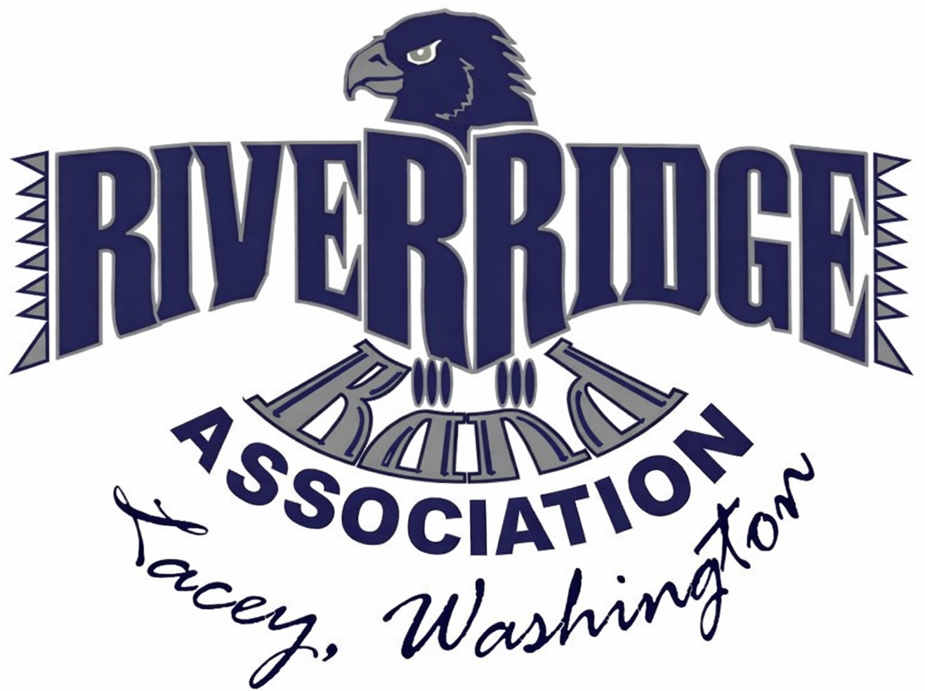
RRBA Membership Policy

Purpose
This policy defines membership categories, rights, responsibilities, volunteer expectations, and standards for good standing.

Section 1 - Membership Categories

1.1 Household – Membership
Parents, guardians, and adults age 21 or older associated with a student currently enrolled in the River Ridge High School band program.
Definition of Household:
For purposes of membership and volunteer requirements, a household consists of all individuals living at the same residence and sharing living expenses, regardless of relationship, who are associated with a student enrolled in the band program.
Rights and Privileges:
- Attend Association meetings and events;
- Serve on committees;
- Have up to two (2) household representatives;
- Participate in discussion;
- Vote, subject to household representation and conflict-of-interest provisions;
- In the event that two board members are from the same household, the household shall be entitled to a single combined vote on all matters requiring board action.

1.2 Advisor Membership
North Thurston Public Schools employees, including band directors and advisors.

Rights and Privileges:
- Attend meetings and events;
- Serve on committees in advisory (non-voting) roles;
- Participate in discussion;
- Not vote or hold elected office.

1.3 Community Membership
Alumni, community supporters, extended families, and business representatives who are not household members with any currently enrolled band students.

Rights and Privileges:
- Attend meetings and events;
- Serve on committees in advisory (non-voting) roles;
- Participate in discussion;
- Not vote or hold elected office.

Section 2 - Membership Contribution Requirement (SAP-Aligned Policy)

2.1 Contribution in Lieu of Monetary Dues
In lieu of monetary dues, the River Ridge Booster Association (RRBA) uses a volunteer-based contribution model to support band program operations and to allow families to earn support for their participating student(s), in alignment with the Association’s Student Account Program (SAP) policy.
Each household member (age 21 or older) is expected to contribute four (4) volunteer hours per quarter, for a total of sixteen (16) volunteer hours per school year, to remain in good standing. Volunteer hours must be submitted using the RRBA-approved volunteer tracking form or system, and they are reviewed and maintained by the Membership Director (or a Board-designated officer).

Volunteer service must directly support:
- The band program and its students;
- Association-sponsored activities, fundraising, or events;
- Administrative, logistical, or operational needs that benefit band students collectively.

2.2 Families with Multiple Enrolled Students
Recognizing the increased level of support associated with multiple participating students, the volunteer encouragement is adjusted as follows:
- One enrolled student: 16 total hours per school year
  - Two or more enrolled students: 24 total hours per school year
No household shall be required to contribute more than twenty-four (24) volunteer hours in a single school year.
2.3 Approved Summer Service
Members may fulfill part or all of their annual volunteer requirement through Board-approved summer service activities, including but not limited to:
- Band camp support;
- Fireworks or seasonal fundraisers;
- Equipment, uniform, or logistical preparation;
- Other activities designated by the Board.
Summer service hours may be credited toward the applicable school-year requirement in accordance with SAP guidelines.

Section 3 -Hardship Waivers
Members experiencing personal difficulty may request a partial or full waiver.
- Requests must be submitted in writing.
- Requests will be reviewed confidentially.
- Waivers require approval by a majority vote of the Board.

Section 4 - Members in Good Standing
A member is considered in good standing when they:
- Support RRBA mission;
- Meet volunteer requirements, or approved waiver;
- Participate in approved activities benefiting band students;
- Comply with Association and district policies.
- Attend 5 out of 9 general membership meetings
Members in good standing retain voting rights, eligibility for leadership roles, and access to SAP-related benefits, subject to policy limits.

Section 5 - Members Not in Good Standing
A member may be designated not in good standing due to:
- Failure to meet volunteer requirements;
- Misconduct or policy violations;
- Violations of school district or Association policies.
- Not attending 5 out of 9 meetings
Loss of good standing may include, but not be limited to, loss of voting rights, leadership eligibility, and SAP participation.
Section 6 - Event-Specific Guest Helpers (Non-Members, Event-Specific)
Non-members (including visiting family members or guests) may assist with limited, non-supervisory tasks at a single event, subject to the following conditions:
- Must be pre-approved by the Band Director or RRBA designee
- Must remain under the direct supervision of an approved RRBA member or staff
- May not supervise students, transport students, or take custody of students
- May not handle money, access confidential information, or perform safety-sensitive duties
- Must follow all NTPS and RRBA conduct expectations while present
- Must sign an Event-Specific Guest Helper Acknowledgment prior to participation
Guest Helpers do not earn volunteer hours, are not considered RRBA members, and are not covered under RRBA volunteer privileges beyond the approved event and task.

Section 7 - Return of Property
All Association property must be returned within five (5) business days of an event.

Section 8 - Behavioral Review Meeting
Incident Reporting: Any incident involving misconduct, safety concerns, or violations of RRBA policies must be promptly reported in accordance with the Association’s Chain of Command and Volunteer/Chaperone policies.
Board Review and Action: Upon receiving a report, the Board may conduct an internal review, document its findings, and take corrective action as deemed appropriate, up to and including suspension or removal of privileges.
Law Enforcement Involvement: Incidents involving alleged criminal conduct, threats to student or participant safety, or mandatory reporting requirements shall be referred to law enforcement and/or appropriate authorities. The Board shall not interfere with any external investigation.
Independent Authority: Board action may proceed independently of any law enforcement or external investigation and is not contingent upon the outcome of such proceedings.

Section 9 - Policy Review and Modification
The Board may propose changes to this policy.
The RRBA Membership Policy shall be reviewed at least once every three (3) years, or sooner as needed by the Board to ensure continued alignment with the Association’s mission, operational needs, and North Thurston Public Schools (NTPS) requirements.
Proposed amendments to this policy may be initiated by the Board or a standing committee authorized by the Board.
All proposed changes must:
- Be presented in writing to the general membership at least thirty (30) days prior to a vote;
- Clearly identify the sections proposed for modification and the rationale for the change.
Adoption of amendments requires approval by a super-majority vote of the members present at a duly noticed general membership meeting, in accordance with the RRBA Bylaws.
Once adopted, revisions shall take effect on the date specified in the approved motion and shall be incorporated into all official Association documents, forms, and publications.
All proposed changes must be presented in writing to the general membership at least 30 days prior to a vote and approved by a super-majority of members present.

RRBA: Volunteer & Chaperone Policy

Purpose
To ensure a safe environment and establish clear, consistent expectations for all individuals supporting RRBA activities, while maintaining alignment with North Thurston Public Schools (NTPS) requirements.

Definitions
  - Volunteer
An NTPS-approved individual who is a current member of RRBA and supports band activities without pay. Volunteers assist with logistics and program support but do not directly supervise or take custody of students.
  - Chaperone
An approved adult who is a current member of RRBA and who directly supervises students during off-campus activities, trips, or events. Chaperones are responsible for the direct care and safety of assigned student group(s) under staff supervision.
  - Event-Specific Guest Helper (Non-Member)
A non-member (including visiting family members or guests) who is approved to assist with limited, non-supervisory tasks at a single event. Guest Helpers do not supervise students, do not take custody of students, and serve only under direct supervision.

General Expectations
- Duty of Care
- All chaperones and volunteers share responsibility for promoting a safe environment.
- Chaperones hold primary supervisory responsibility for students.
- Volunteers and Guest Helpers provide only supporting assistance.
- Confidentiality
- Chaperones may receive limited student health information on a need-to-know basis.
- Volunteers typically do not receive student health information unless directly relevant to their assigned task.
- All student information is confidential and may only be shared with authorized staff.
- Supervision
- Chaperones must remain with their assigned student group(s) at all times.
- Volunteers and Guest Helpers must never take unsupervised custody of a student or student group unless explicitly directed by staff.
4. Responsibilities
4.1 Chaperone Responsibilities
Chaperones are expected to:
- Be aware of health alerts for students in their assigned group.
- Monitor students for signs of distress (e.g., breathing difficulties, allergic reactions, seizures).
- Immediately notify staff if a student shows symptoms of a health emergency.
- Not administer medication unless trained and authorized by NTPS.
- Call 911 if staff are unavailable and the situation is life-threatening.
- Remain with the student until help arrives.
- Carry out supervision responsibilities with care, accountability, and professionalism.
4.2 Volunteer Responsibilities
Volunteers are expected to:
- Remain alert to overall student safety in the activity area.
- Report any observed safety or health concerns immediately to a chaperone or staff member.
- Assist with logistics, including equipment, concessions, fundraising, uniforms, and event support.
- Not supervise students, intervene medically, or take custody of students.
4.3 Event-Specific Guest Helper Responsibilities
Event-Specific Guest Helpers must:
- Be pre-approved by the Band Director or an RRBA-designated officer.
- Remain under supervision of an approved RRBA member or staff at all times.
- Not supervise students, transport students, or take custody of students.
- Not handle money, access confidential information, or perform safety-sensitive duties.
- Follow all NTPS and RRBA conduct expectations while present.
- Sign an Event-Specific Guest Helper Acknowledgment prior to participation.
5. Standards of Conduct
All volunteers and chaperones must:
- Maintain NTPS volunteer clearance and follow sign-in procedures and staff directions.
- Act respectfully toward students, staff, parents, and fellow volunteers.
- Foster an inclusive, supportive, and positive environment.
- Prioritize student safety, well-being, and independence.
- Support RRBA’s mission, goals, policies, and procedures.
6. Physical Contact Guidelines
Professional Boundaries in accordance with NTPS guidelines:
- Avoid front-facing hugs.
- Use side hugs only (arm around the shoulder).
- Never allow students of any age to sit on your lap.
- Acceptable contact is limited to the shoulder, upper back, arms, and hands.
7. Prohibited Actions
The following actions are strictly prohibited:
- Administering medication unless explicitly authorized and trained by NTPS.
- Sharing confidential student information with unauthorized individuals.
- Leaving students unsupervised (chaperones).
- Taking custody of students (volunteers or Guest Helpers).
8. Training & Acknowledgment
- All chaperones and volunteers will receive a pre-event safety briefing from staff.
- Chaperones will be briefed on relevant student health needs for their assigned group(s).
- Each chaperone, volunteer, and Event-Specific Guest Helper must sign the appropriate acknowledgment form prior to participation.
9. Incident Reporting
Any health-related incident or safety concern must be reported immediately to supervising staff and the Band Director and documented in accordance with NTPS and RRBA procedures.
10. Policy Review and Modification

10.1 The Board may propose changes to this policy.
The RRBA Volunteer & Chaperone Policy shall be reviewed at least once every three (3) years, or sooner as needed by the Board to ensure continued alignment with the Association’s mission, operational needs, and North Thurston Public Schools (NTPS) requirements.
Proposed amendments to this policy may be initiated by the Board or a standing committee authorized by the Board.

10.2 All proposed changes must:
- Be presented in writing to the general membership at least thirty (30) days prior to a vote;
- Clearly identify the sections proposed for modification and the rationale for the change.
Adoption of amendments requires approval by a super-majority vote of the members present at a duly noticed general membership meeting, in accordance with the RRBA Bylaws.
Once adopted, revisions shall take effect on the date specified in the approved motion and shall be incorporated into all official Association documents, forms, and publications.
All proposed changes must be presented in writing to the general membership at least 30 days prior to a vote and approved by a super-majority of members present.

RRBA: Volunteer Acknowledgment Form

Student Safety & Health-Related Emergencies

Purpose
This form confirms that all adults serving as chaperones or volunteers understand their responsibilities for ensuring student safety and responding appropriately during health-related emergencies. This form will be kept on file and will apply to all events during the current school year.
General Responsibilities (All Helpers)
By signing this form, I agree to:
- Follow all NTPS and RRBA policies, rules, and staff directions.
- Maintain professional boundaries and confidentiality.
- Report safety or health concerns to staff immediately.
- Remain attentive and act in the best interest of student safety at all times.
- Never administer medication or provide medical treatment unless explicitly authorized and trained by NTPS.
Volunteers (Support Role)
- I understand that I am assisting with activities and logistics, but do not directly supervise students.
- I will remain alert to student safety and immediately report concerns to staff or a chaperone.
- I will not take custody of students unless directed by staff.
- I will not request or accept confidential student health information.
Volunteer Acknowledgment & Signature
I have read and agree to follow the above responsibilities as a volunteer.
Printed Name: _________________________________________
Signature: _____________________________________________________________ Date: __________

RRBA Guest Helper Acknowledgment Form

Event-Specific Guest Helper Acknowledgment

Purpose
This form applies to non-members, including visiting family members or guests, who are approved to assist with limited, non-supervisory tasks at a single RRBA event.

Event Information
Event Name: ___________________________________________ Event Date: ___________________
Band Director / RRBA Designee Approval: ☐ Yes

Acknowledgment
By signing below, I acknowledge and agree that:
- I am not an RRBA member and am assisting only as an Event-Specific Guest Helper.
- My assistance is limited to non-supervisory tasks and applies only to the event listed above.
- I understand that I:
  - May not supervise students, transport students, or take custody of students.
  - May not handle money, access confidential information, or perform safety-sensitive duties.
  - Must remain under the direct supervision of an approved RRBA member or staff at all times.
- I agree to follow all NTPS and RRBA conduct expectations while present.
- I understand that failure to comply may result in immediate removal from the event and loss of permission to assist at future events.
Guest Helper Acknowledgment & Signature
I have read and agree to follow the above responsibilities as a volunteer.
Printed Name: _______________________________________
Signature: ___________________________________________ Date: ___________________

RRBA Trips & Off-Campus Events
For band director use only

Chaperone Quick Guide

Purpose
This summary outlines expectations, supervision standards, and emergency procedures for all RRBA volunteers and chaperones participating in trips or off-campus events. Student safety and compliance with NTPS and RRBA policies are the top priorities at all times.
Supervision Expectations
- Volunteers and chaperones must remain actively engaged and aware of assigned students at all times.
- Students must never be left unsupervised.
- Supervision assignments (groups, areas, or duties) are determined by the Band Director or designee and must be followed as directed.
- Volunteers may not substitute, reassign, or delegate supervision duties without approval.
- Personal activities (phones, socializing, errands) must not interfere with supervision responsibilities.

Authority & Chain of Command
- The Band Director has full authority over all student supervision decisions during trips and off-campus events.
- Volunteers and chaperones act in a support role only and must follow instructions from the Band Director or designated staff.
- Concerns or incidents should be reported immediately through the established chain of command.

Emergency Response Reminders
In any emergency situation:
- Ensure student safety first
- Contact the Band Director or the nearest staff member immediately
- Call 911 if there is an immediate threat to health or safety
- Do not administer medication or medical treatment unless authorized and trained
- Do not release a student to anyone without approval from the Band Director or school officials
Volunteers must follow all NTPS emergency procedures and cooperate fully with school staff and emergency responders.

Conduct Expectations
- Maintain professional, respectful behavior at all times.
- Follow all RRBA, NTPS, and school district rules.
- No alcohol, drugs, or impaired supervision.
- Confidential student information must be protected.

Acknowledgment
Participation in a trip or off-campus event confirms agreement to follow all RRBA Volunteer & Chaperone Policies and Band Director Instructions.
Printed Name: _______________________________________
Signature: ___________________________________________ Date: ___________________

RRBA Public Events: Volunteer Guidelines
One-Page Quick Reference

Your Role as an RRBA Volunteer
RRBA volunteers represent River Ridge High School, the Band Program, and RRBA. Volunteers support events through logistics and assistance, but do not supervise or take custody of students. Your conduct directly impacts student safety and our community reputation.

Volunteer Must-Do’s
Volunteers are expected to:
- Model respectful, professional behavior at all times
- Remain visible, approachable, and available to families and staff
- Redirect unsafe or inappropriate behavior promptly and respectfully, and notify staff
- Keep all interactions with students appropriate and aligned with NTPS expectations
- Report concerns or incidents immediately to the Event Lead
Student Safety Expectations
- Volunteers may not supervise students in place of a parent, guardian, or chaperone
- Volunteers must never take custody of a student or student group
- Students must not be left unattended in public areas
- All safety concerns must be reported to a chaperone or staff member without delay

Transportation Rules
Volunteers may not:
- Transport students who are not their own children
- Arrange carpools as an RRBA-sponsored activity
- Create the appearance of RRBA-provided or endorsed transportation
All student transportation is coordinated by families or school-approved providers.

Professional Conduct
Volunteers must:
- Use respectful language and behavior at all times
- Avoid profanity, confrontational behavior, or public disputes
- Refrain from alcohol, cannabis, or tobacco use while volunteering
- Not discuss student discipline, health, or confidential matters
- Foster a welcoming, inclusive, and positive event environment
Social Media Guidelines (See Media Policy)
- Do not post photos or videos with student-identifying information without parent or guardian consent
- All posts should be positive and reflective of RRBA values
- When in doubt, do not post

If a Concern or Incident Occurs
Immediately notify:
- Event Lead
- Band Director (for any student-related concern)
- RRBA President (for escalations or serious issues)
Written documentation may be required in accordance with NTPS and RRBA procedures.

RRBA Volunteer Hour Logging Form

Volunteer Information
Name: Phone:
Email:
Student Name: Student Grade: ______
Student Name: Student Grade:
Student Name: Student Grade: ______
Volunteer Hours Log
Date | Event / Activity | Description of Work | Hours | Initials of Event Lead
Total Hours: ____________

Summer Service (if applicable)
Approved Summer Activity: __________________________________________
Date(s): ___________________ Hours: ____________
Approved Summer Activity: __________________________________________
Date(s): ___________________ Hours: ____________

Verification
I certify that the above volunteer hours are accurate and were completed as described.
Volunteer Signature:
Date: _______________
Approved By (Membership Director or Board Designee): ______________________________________
Date: _______________

Documentation shall be submitted to the Membership Director at the conclusion of the event or, at the latest, by the next regularly scheduled meeting.

RRBA Chain of Command & Incident Reporting
Volunteer Quick Reference

Why This Matters
Clear communication keeps students safe and ensures concerns are handled quickly, appropriately, and in compliance with RRBA policy and North Thurston Public Schools (NTPS) requirements.
Volunteers do not investigate incidents or take disciplinary action. Your role is to observe, report, and escalate.

Chain of Command (Who to Contact)
Follow this order unless there is an immediate emergency:
- Event Lead (leader)
  - First point of contact for all concerns
  - Coordinates volunteers and onsite response
- Chaperone
  - For student supervision or student-related concerns
  - Responsible for direct student care
- Band Director / School Staff
  - Required contact for any student safety, health, or behavioral issue
  - Has final authority on student matters
- RRBA President
  - Contact for escalations, policy concerns, or serious incidents
  - Supports coordination with the Board if needed
If you are unsure who the Event Lead is, contact any RRBA officer or staff member immediately.

Emergency Situations
Call 911 immediately if:
- A student or adult is in immediate danger
- There is a medical emergency and staff are unavailable
- A serious injury or safety threat occurs
After emergency services are contacted:
- Notify the Event Lead
- Notify the Band Director
- Remain available to provide information

What to Report
Volunteers must report immediately:
- Student injuries or illness
- Safety hazards or unsafe behavior
- Missing or unattended students
- Boundary or conduct concerns
- Any situation that “doesn’t feel right.”
Do not wait to see if the situation resolves on its own.

How to Report
When reporting, be ready to share:
- What you observed (facts only)
- Location and time
- Who was involved
- Any immediate actions taken
Do not:
- Question students extensively
- Share information with other volunteers or parents
- Post about the incident on social media
Documentation
- Written documentation may be required by NTPS or RRBA
- Complete any requested forms promptly and accurately
- All reports are handled confidentially and shared only with authorized individuals

Key Reminders for Volunteers
- Do not supervise or take custody of students
- Do not administer medication
- Follow staff direction at all times
- When in doubt: report it

Thank You for Volunteering
Your awareness and prompt reporting help keep RRBA events safe, organized, and supportive for all students

